#I have one big question. **How have countries contributed to space exploration? We will look at it in terms of budget, mission types, success rates, environmental impact and technology use.**

#All 10 analysis questions will be used to answer that one big question.

#Which country has conducted the most space missions?

#Which country has invested the highest total budget in space missions?

#What is the trend of total space mission budgets over the years?

#Which mission type (Manned or Unmanned) is more common, and how does it vary across countries?

#What are the success rates of space missions, and which countries achieve the highest success?

#How do satellite types vary across countries?

#Which launch sites are the most frequently used?

#What are the trends in the use of advanced technologies (Reusable Rocket, AI Navigation, Solar Propulsion) over the years?

#What is the environmental impact of space missions across different countries?

#Which missions have the longest duration, and what factors contribute to them?

—----------------------------------------------------------------------------------------------------------------------------

**#Which country has conducted the most space missions?**

We can see that China and the UK have conducted the most space missions (322), followed by Israel, France, UAE and USA.

—----------------------------------------------------------------------------------------------------------------------------

**#Which country has invested the highest total budget in space missions?**

Not surprisingly, China and the UK had the most budget invested for space missions.

But, it's interesting to see that France was the third country that spent the most for the space mission even though the number of missions was less than Israel.

USA and India were the 4th and 5th countries that spent the most on space missions.

This acknowledges that even though the number of missions is relatively low compared to the other top countries, they allocated a significant amount of budgets.

—----------------------------------------------------------------------------------------------------------------------------

**#What is the trend of total space mission budgets over the years?**

We can say that the total budget trends are up and down and it may be due to many reasons.

2000-2005: 2,688?3,123 billion dollars annually.

2006-2010: 2,521?3,312 billion dollars annually.

2011-2015: 2,730?3,589 billion dollars annually.

2016-2020: 2,634?3,317 billion dollars annually.

2021-2025: 2,312?3,291 billion dollars annually.

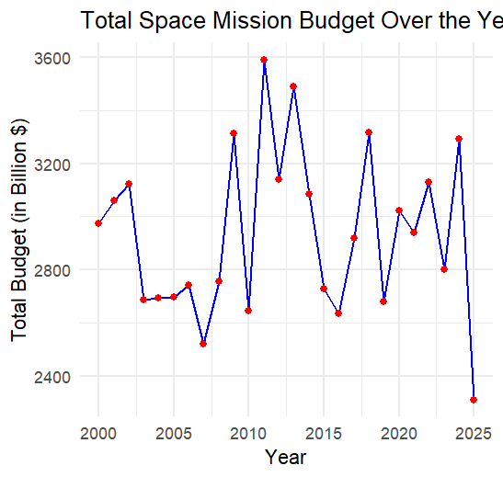

—----------------------------------------------------------------------------------------------------------------------------

**#Which mission type (Manned or Unmanned) is more common, and how does it vary across countries? #Manned = human involved, unmanned = no human involved**

We can say that Israel, Uk and USA have more manned missions.

China, UAE and Japan have more unmanned missions.

Typically, manned missions are good for complex problems and unmanned missions can be useful to explore potentially hazardous environments.

—----------------------------------------------------------------------------------------------------------------------------

**#What are the success rates of space missions, and which countries achieve the highest success?**

We can say that on average, Germany has the highest average success rate of 76.2%. It means that it has a consistent success rate compared to others.

India, France and Russia are followed after Germany.

#I am interested in the success rate based on the mission type.

Manned mission type has a higher average success rate but it's not a big gap.

—----------------------------------------------------------------------------------------------------------------------------

**#How do satellite types vary across countries?**

Satellite types are used for different purposes. Each country has their own priorities.

Russia and USA focus more on research satellites while France prioritizes spy satellites.

The UK has multiple satellite types such as weather, research and spy.

—---------------------------------------------------------------------------------------------------------------------------

**#Which launch sites are the most frequently used?**

West Michael has hosted the most missions, 5.

Then, it is followed by Ashleymouth, Michaelview, New James, New Michael, New Steven (4).

We can say that many launch sites were used and the missions weren't happening in just one location.

This may be to avoid the delays of the missions.

—----------------------------------------------------------------------------------------------------------------------------

**#What are the trends in the use of advanced technologies over the years?**

# We will count the number of missions for each technology used

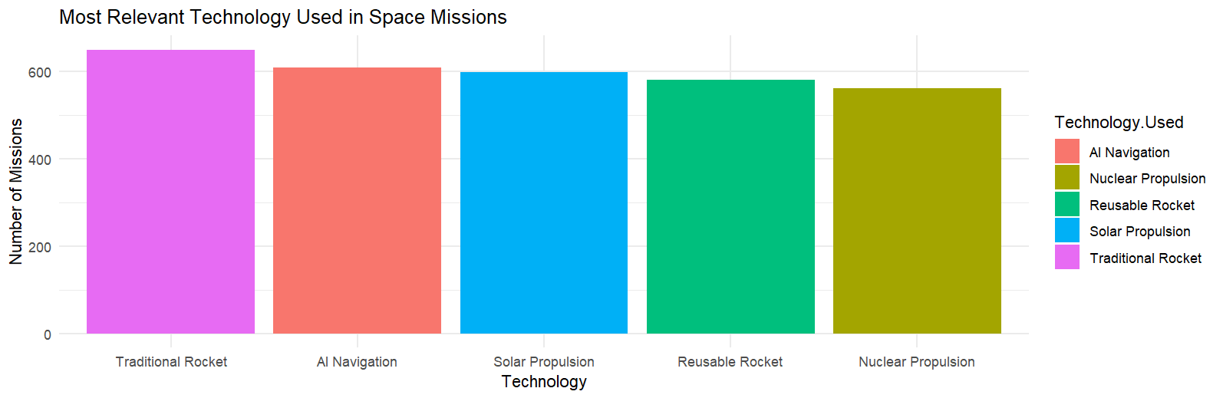

Tradition Rocket is the most used technology, 650 followed by AI Navigation.

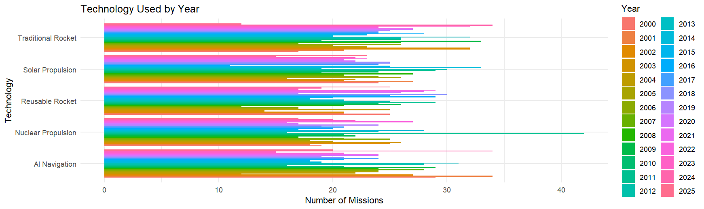

—----------------------------------------------------------------------------------------------------------------------------

**#What is the environmental impact of space missions across different countries?**

The UK and UAE have most missions with medium and low environmental impact.

China and Israel have a mix of all environmental impacts.

Overall, most countries have medium or low environmental impact.

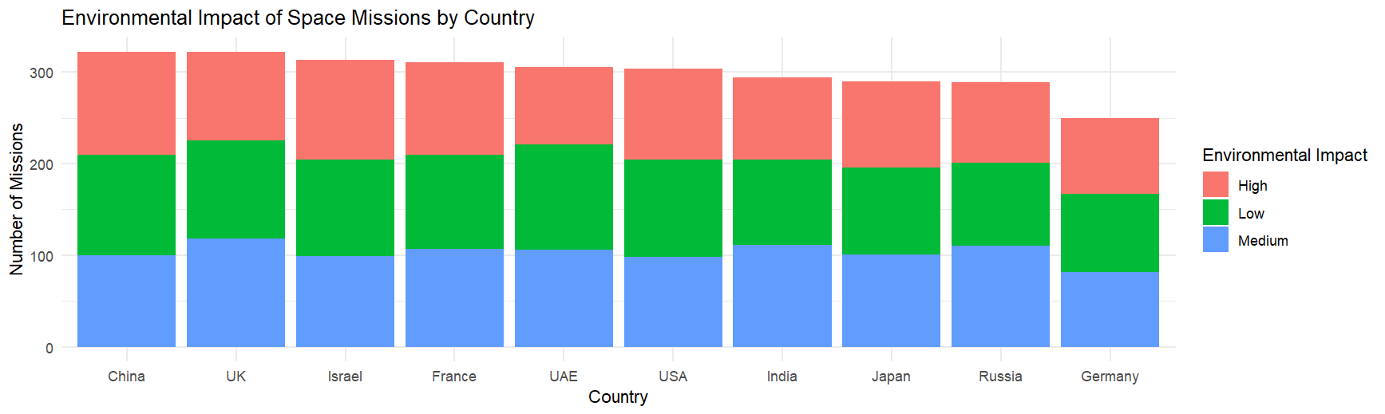

—----------------------------------------------------------------------------------------------------------------------------

**#Which missions have the longest duration, and what factors contribute to them?**

The longest mission is 365 days.

It's both unmanned and manned mission types.

Unmanned missions typically last longer. It may be due to the lack of necessity for humans.

Manned missions tend to have a greater environmental impact.

—----------------------------------------------------------------------------------------------------------------------------

**#Insight:**

#1. China and the UK lead in space missions, suggesting they have strong programs.

#2. Despite fewer missions, France, the USA, and India invest heavily in space exploration.

#3. Manned missions are often carried out by the USA, UK, and Israel, while unmanned missions dominate in countries like China, UAE, and Japan.

#4. Germany has more successful missions, and there is a growing trend of using advanced technologies like AI and reusable rockets even though the traditional rocket usage is most relevant.

#5. Missions have different purposes. So, they use different satellites. Most missions aim for low to medium environmental impact.

**#Recommendation:**

#1. Small countries with limited budget should collaborate so that they can share costs and expertise.

#2. Countries should focus on reusable rockets for greener rockets that help reduce environmental impact.

#Note: I have used only count(), arrange(), group_by(), summarise() since using only them is enough for the analysis.

#However, we can also use filter() to filter out whatever numbers we want for interactive purposes.